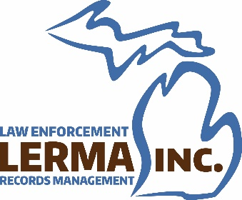
INVOICE – 2025 Member Agency Dues

Invoice Date: September 19, 2024 LERMA Tax ID # 38-3190154
Payment Due Date: January 31, 2025 Amount Owed: $75.00
AGENCY NAME: _________________________________________________
MEMBER INFORMATION
MEMBER NAME* | MEMBER EMAIL ADDRESS
*If needed, add additional members on a second sheet and return with invoice
The Law Enforcement Records Management Association (LERMA) of Michigan is a statewide nonprofit organization which was formed in 1993 and incorporated in 1994. Our purpose is to bring law enforcement records professionals together to increase their knowledge and efficiency.
LERMA meetings are scheduled three times a year to educate our members and assist members agencies with innovative solutions to challenges faced by records professionals. Our website and email communications ensure that members remain abreast of ever-changing laws and procedures.
Member dues are $75 annually and are charged per agency, not per member. LERMA has proven to be an asset to all who have joined and is well worth the investment. Renew your membership today!
Payment Options
- Pay online at lermainc.org
- Mail a check made payable to LERMA, Inc. to:
Nihada Lilic, LERMA Treasurer
Kent County Sheriff's Office
701 Ball Ave NE
Grand Rapids, MI 49503
Thank you for remaining a LERMA member! We truly are better TOGETHER.

